NORTH-EAST TOUR PACKAGE
TAWANG (7NIGHTS-8DAYS)
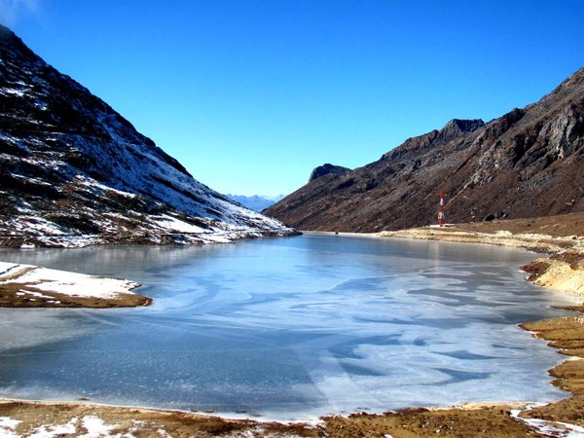
Day 1: Meet our representative at Guwahati Railway station/Airport after arriving in the morning and drive to Bomdila and visit Bomdila monastery if possible. Check in hotel and overnight stay.
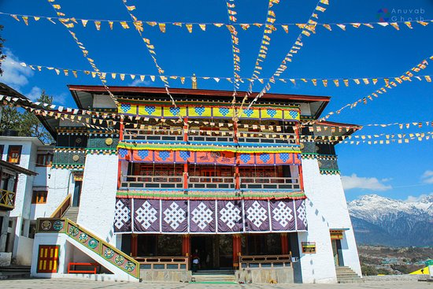
Day 2: After breakfast check out hotel and transfer to Tawang. En-route visit the Sela Pass-the 2nd highest motor able road in the world besides Sela lake and Jaswant Garh war memorial. Check in hotel and overnight stay.
Day 3: After breakfast enjoy the full day city tour- Tawang Monastery which is 400 years old, P.T Tso Lake, Urgelling Gompa (Six Dalai Lama’s birth place), local market, craft center. At evening visit Tawang war memorial and enjoy the light & sound show at War Memorial. Back to hotel and night stay.
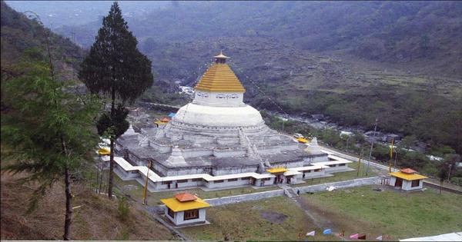
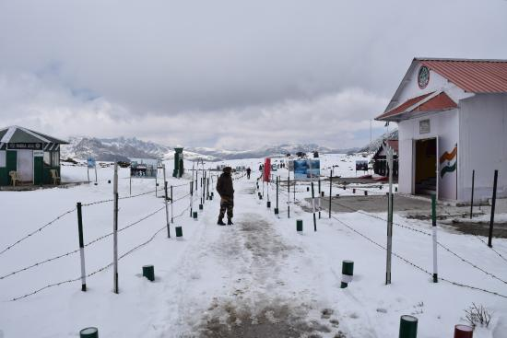
Day 4: After breakfast start the day with a journey to Bum La Pass (Indo-China Border) en-route with Shong-Tser Lake also known as Madhuri Lake. At the border Snowfalls occur here during summer also. The picturesque view also famous for photography. After enjoying the nature return back to hotel and overnight stay.
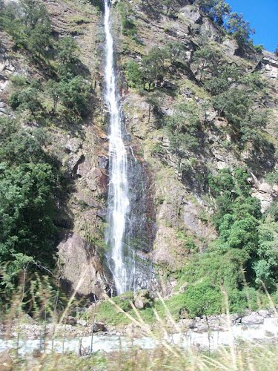
Day 5: In the early morning drive to the Zemithang Valley en-route with the BTK water fall. The main attraction of the valley is Gorsam Chorten.
Day 6: After breakfast check out hotel and drive to Dirang en-route visit the Nuranang falls at Jang. Check in hotel and overnight stay.
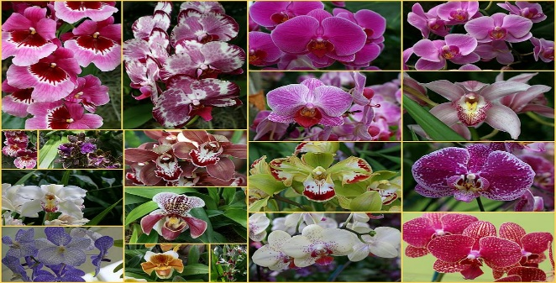
Day 7: Check out hotel and transfer to Bhalukpung en-route visiting Tipi Orchid garden. Check in hotel and night stay.
Day 8: Check out hotel early in the morning and transfer to Guwahati railway station/airport for the final journey.

